Newsletter
October 2017

Newcomers.
Firstly I would like to say that all our new p1’s and new starts at Schools’ Out! have settled well with some not even wanting to go home when collected, which is always great to see. They must be happy!

How time flies!
Its October already! Your child may start to bring their group mascot home for a visit as part of their personal profile, this continues with them throughout their time with us at Schools’ Out! We hope they are all excited about taking part and the fun activities to follow.

P7 club!
Our P7 children will not be participating in taking home a mascot as this has not proven popular amongst the older children in the past. They will however have their own group lead up by our newest member of staff, Chantelle. Chantelle will strive to provide age appropriate activities to this particular group. We look forward to seeing what they have in store for our next newsletter.

Breakfast Club!
A gentle reminder that all children wishing to enjoy our breakfast before they go to school must be dropped off prior to our kitchen closing at 8:30am.

Outdoor Play!
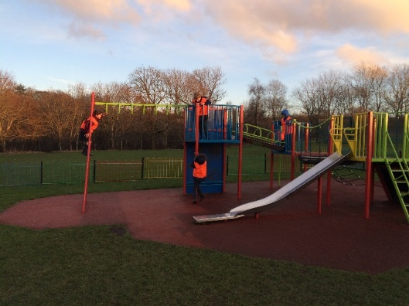
We are trying to promote outdoor play in all kinds of weather. Please feel free to pop a change of clothes in your child’s bag to help keep uniforms clean as our outdoor area can get quite muddy!

Well Done!
A huge well done to Pat McMillan, Irene Wilson and Angela Jamieson for completing their Outdoor Paediatric First Aid Course.
Further congratulations to Elaine Hunter and Chantelle Allan on completing The Play Workers Toolkit Course. A very interesting course looking at why children play and the benefits of play. This course has a second block named The Glory of Play and is more advanced, which our Manager, Natalie, will also attend alongside Elaine & Chantelle.

We have a great team of staff here at Schools’ Out! Further details can be found on our website along with updated information about what’s happening in our play settings.
www.schoolsoutchildcare.co.uk

Should you have any questions, complaints or enquiries please contact our Manager Natalie by email. Schools.out@hotmail.co.uk She will be happy to deal with all issues accordingly.

Thank you!

Natalie Scanlan

